35.61: There are two effects to be considered: first, the expansion of the rod, and second, the change in the rod’s refractive index. The extra length of rod replaces a little of the air so that the change in the number of wavelengths due to this is given by:
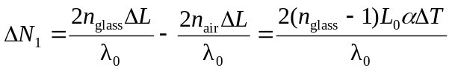
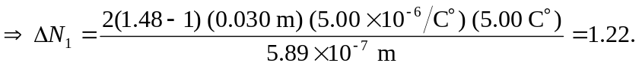
The change in the number of wavelengths due to the change in refractive index of the rod is:
So the total change in the number of wavelengths as the rod expands is 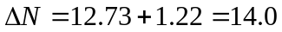 fringes/minute.

